|  |
| --- |
|  |
| ALLERTON  CONGREGATIONAL CHURCH |

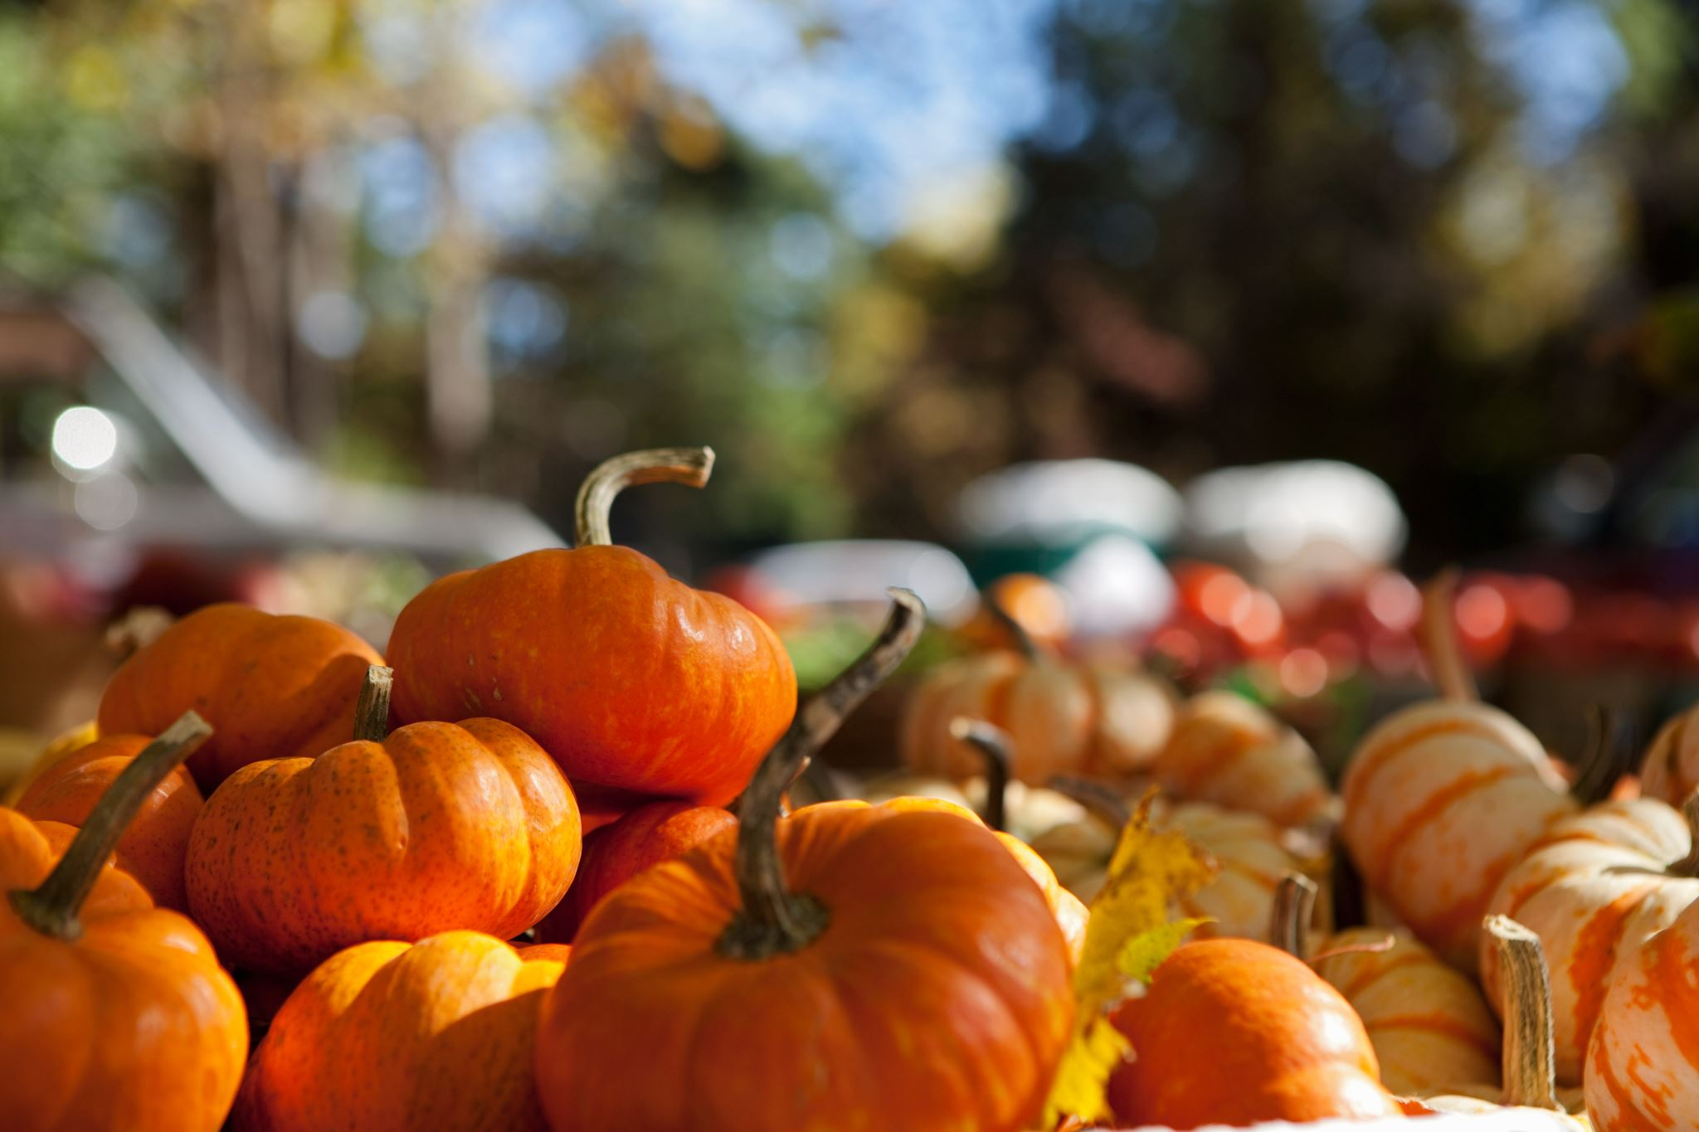

October/November 2023 Newsletter

Dear Friends

When people know that we are Christians they might ask us why there are so many different churches or denominations? People look around at the different sorts of fellowships that there are and get thoroughly confused. We are an unaffiliated, or independent, Congregational church. Locally to us there are Anglican (Church of England) churches, Methodist churches, Baptist churches, Catholic churches and many others besides. Other groups claim to be Christian, but are not, because they deny that Jesus is God. These include the Jehovah’s Witnesses, Christian Scientists and the Mormon church (Church of Jesus Christ of Latter-day Saints).

So, what makes an organisation a Christian church, and how can we define these basic beliefs that make us Christian? Basically, it comes down to beliefs about God, salvation and the Bible. Our foundation for what we believe needs to come from God’s Word (the Bible) and what God has revealed to us there. At the very end of the Bible, in the book of Revelation, we are given a stern warning by God, “if anyone adds to them, God will add to him the plagues described in this book, and if anyone takes away from the words of the book of this prophecy, God will take away his share in the tree of life and in the holy city, which are described in this book.” (Revelation 22:18-19).

These serious words of warning echo what God said to Moses, which we find in the book of Deuteronomy, “And now, O Israel, listen to the statutes and the rules that I am teaching you, and do them, that you may live, and go in and take possession of the land that the Lord, the God of your fathers, is giving you. You shall not add to the word that I command you, nor take from it, that you may keep the commandments of the Lord your God that I command you.” (Deuteronomy 4:1-2) The key principle here is that we are to neither add to God’s Word nor take away things from it.

Both the Mormons and the JWs do this by adding their own extra books and testimonies that include teachings that go against what God has revealed to us in Scripture. There is also the question of who God is, and what He is like. Again, we need to look first and foremost to the Bible for answers.

God is One (Deuteronomy 6:4), and yet He reveals Himself to us in three persons, Father, Son and Holy Spirit. They all exist together at the same time and are separate persons, and yet somehow there is still only One God. This is beyond the understanding of the cleverest theologians and Bible teachers, but it is what we are clearly told in Scripture. God is holy, loving, gracious and just amongst other things.

Then we come on to the matter of salvation, and yet again we need to look to what God has shown us in the Bible. Put simply, the Gospel by which we may be saved is this: we are all sinners, whose sin separates us from the One true holy God. Yet because of His love and grace He sent His Son, Jesus, to die in our place on the cross, paying the price for our sin.

Through faith in Jesus Christ alone, and not because of anything that we have done, our sins are forgiven, and we enter into eternal life as God’s adopted children.

Any ‘church’ or teacher that teaches a different ‘gospel’ is accursed or devoted to destruction (see Galatians 1:8-9). This does raise some tricky questions about some historic Christian denominations that no longer hold to these beliefs about the Bible, God and salvation. It is important for us to constantly and consistently compare the teachings of churches and their leaders against the Bible, as new approaches are taken in response to the world in which we live. If these beliefs don’t match up with the Bible, we should reject them and separate from those who hold to them.

There are, of course, many churches that do hold to these right beliefs about God, salvation and the Bible and we do well to fellowship with and support these brothers and sisters in Christ. So, these are the key beliefs that make churches Christian. How then should we answer people who ask why there are so many different denominations?

Firstly, we can point to the core beliefs that unite us, and then secondly, we can explain that other beliefs and practices are debatable. For example, we can hold different views on baptism, whilst still having the same beliefs about God, salvation and the Bible. People also have different preferences about music, style and dress, and can yet hold to the same core beliefs. That’s why there are so many different denominations, some of which are Christian, and sadly some of which are not.

Fred

Secretary’s Thoughts

I can hardly believe we are in October – where has this year gone? My Grandma always told me that time went quicker when you got older – obviously I didn’t believe her, but she was right.

We are now being invited for our next round of flu and COVID jabs. We have had ours and I would encourage you all to do the same. We all need to try and keep ourselves well.

Those who were able to attend enjoyed our harvest supper. Our next event is the Christmas Coffee Shop on 25th November and then we are into the Christmas Season and looking forward to celebrating the birth of Jesus.

Janet

**The Christmas Coffee Shop**

The Christmas Gift stall is very short of gifts to sell and would appreciate wrapped gifts for men, woman and children.

Please remember that they are sold for £1 each, so please buy appropriate presents.

Thanking you in anticipation.

Yvonne.

Dates for your Diary

Saturday 25th November – Christmas Coffee Shop – 10am-12noon.

Flower Rota – flowers provided by:

|  |  |  |  |  |
| --- | --- | --- | --- | --- |
| October 23 | |  | November 23 | |
| 1st | Mr & Mrs P Barfield |  | 5th | Mrs J Holdsworth and Mrs & Mrs A Jones |
| 8th | Mr & Mrs B Haley |  | 12th | Mrs I Relton |
| 15th | Mrs Brown |  | 19th | Mr & Mrs I Hastings |
| 22nd | Mrs A Henderson |  | 26th | Mrs M Fletcher |
| 29th |  |  |  |  |

On Sundays not listed, silk flowers will be used.

Preaching list

|  |  |  |  |  |
| --- | --- | --- | --- | --- |
| October 23 | |  | November 23 | |
| 1st | Mr Neil Harris |  | 5th | Rev Fred Rich |
| 8th | Rev Richard Lewis |  | 12th | Mr Trevor Hippey |
| 15th | Rev Fred Rich |  | 19th | Rev Fred Rich |
| 22nd | Rev Fred Rich |  | 26th | Mrs Janice LeBlancq |
| 29th | Mr Trevor Kershaw |  |  |  |

Finance Committee

The asbestos found in the cellar has now been successfully made safe and this will now allow the first part of the electrical works to be progressed. This will involve having the electric meters changed to Smart Meters, although as with most things this may not be straightforward, and we are having discussions with SSE.

Coffee Rota

As we continue to have coffee after services, it would be helpful if those on the rota could come a little earlier to set things up. You will not need to bring milk.

The coffee rota is on the notice board in the vestibule and will be on the table in the hall on Sundays.

Bible Reading Rota

If you would like to offer to read the Bible for Sunday services, the Bible reading rota is on the notice board in the vestibule and will be on the table in the hall on Sundays.

Note from the Editor

The next newsletter is due on 26th November 2023 – please let me have any items for inclusion by 19th November 2023.

Thank you – Carole

Sundays - Services at 10.30 am.

Addresses:

Pastor: Secretary & Treasurer: Editor: Fredrik Rich Janet & David Muschamp Carole Brook 1 The Sycamores Thimble Stones View

Riddlesden 56 Rudding Avenue

Keighley Allerton, Bradford BD20 5EF BD15 7DS

01274 542859

01535 531966 07837 441784 (Janet)

07570 801863 07530 727616 (David)

[Frich107uk@sky.com](mailto:Frich107uk@sky.com) [david.muschamp47@btinternet.com](mailto:david.muschamp47@btinternet.com)

## Website: allertoncongregationalchurch.org.uk

 **facebook.com/allertoncongregationalchurch**