ALLERTON
CONGREGATIONAL CHURCH

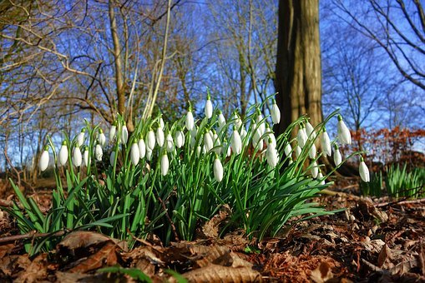
February 2021 Newsletter

Dear Friends

All theology, whether academic or practical and down to earth, seeks to answer the question ‘what is God truly like?’ It’s an impossible question to answer fully or comprehensively, and yet it is a task in which we must engage as God’s people. But how can we, as mere human beings, know what God is like? To get to know someone we spend time with them, talk with them and perhaps even read what they have written about themselves. That’s all fair enough, but when it comes to God what can we do to find out more about Him? First and foremost we need to turn to His Word, the Bible, because it is through this book that He has revealed Himself to us.

When we read the Scriptures, we can point to a number of things that tell us how God acts, what His character is like and so on. At the centre of the descriptions of God is the revelation that He is holy. God spoke to Moses to tell His people Israel, “Be holy because I am holy.” (Leviticus 11:44) What does this mean, or look like in practice? Holiness is being other or separate (unlike anything or anyone else, in a positive kind of way); it is being pure and without blemish; it is being entirely dedicated to, or focused on, God. Although we are called to be holy, only God Himself is truly other, or completely holy.

God cannot be anything other than holy. He cannot do anything that is wrong. He cannot lie, cheat or be unjust towards anyone or anything. He reveals this to us through the life of His Son, Jesus Christ, the image of the invisible God (Colossians 1:15). He lived a perfect life here on earth, without sin or blemish, and because of that He did not deserve to die. “The wages of sin is death” (Romans 6:23), and we are all sinners deserving that just punishment, but Jesus was other – without sin – holy. God’s holiness is seen in a number of ways in Scripture, and amongst those ways is the truth or truthfulness of God.

Jesus Christ, the Son of God, the Messiah, the Word made flesh spoke to his disciples, saying “I am the way, and the truth, and the life. No one comes to the Father except through me. If you had known me, you would have known my Father also. From now on you do know him and have seen him.” (John 14:6-7). We know that salvation comes by grace alone, through faith alone, in Christ alone. Jesus is the only way to eternal life. Jesus was totally otherly, or holy, and He is our only hope to be made holy ourselves. Buddha, Krishna, the angel Moroni, Mohammed and others are of no help whatsoever.

The truth of redemption is only found in Jesus Christ, and it is in Him that God has revealed that truth to the world. Jesus said, ‘I am… the truth’. Scripture tells us that not only is God and His Word true, but also that God cannot lie. This is shown to us in at least three verses – Numbers 23:19, Titus 1:2, and Hebrews 6:18. It is impossible for God to speak anything that is false or untrue. He is not like human beings, who, as we know from our own experiences, certainly do lie on occasions. God is completely other, and whereas our instinct in a sticky situation might be to lie, with God that is impossible.

If we combine this characteristic of God with what the Apostle Paul wrote to Timothy, we can say with certainty that everything in the Bible is also true (see 2 Timothy 3:16). We can fully trust in God and His Word because it is 100% true, unlike the news, history books or even our own words. In the Twenty First Century we seem almost obsessed about the idea of fake news, but with God such a thing is impossible. God’s good news to humanity – the Gospel – is true and cannot possibly be anything else.

Let me leave you with these words of Jesus about the truth. “If you abide in my word, you are truly my disciples, and you will know the truth, and the truth will set you free.” (John 8:31-32) God always speaks the truth, and the truth of the Gospel sets us free from the slavery and shackles of this world. No longer are we forced to be slaves to sin, but we are free to live in obedience to God in Christ. God is holy and calls us also to be holy, or separate from the world around us. Let us not forget the importance of God’s truth, the Gospel, and its power to set us free.

Yours, Fred.
Newsletter Editor

We have received an email from our newsletter editor, Faye Hardy, who has decided that after nearly 22 years of being the church Newsletter Editor, it is perhaps time to pass on the baton to someone else, who still attends church.
Since the first lockdown, things have changed and the role has altered quite
considerably so she has tendered her resignation, which we have accepted with grateful thanks for her service over so many years.
If anyone feels prompted to take on the role, please speak to either of us.
In the meantime, we will continue to produce the newsletter, until a replacement can be found.

Many thanks, Janet and David.
Pauline and Philip Barfield

Pauline and Philip send greetings and best wishes to all at Allerton Congs.

Susan Thorp –30.5.1946 to 27.12.2020

It is with great regret that we record the death of Susan Thorp, who passed away on Sunday 27th December after a long struggle with Parkinson’s Disease, amongst other things. The funeral service was conducted by Trevor Kershaw on Monday 18th January, with a restricted congregation of 14, with a further 5 members attending outside to pay their respects.
Susan was a much loved member of our church family and had been a faithful servant of Christ, all her life. Her contribution to the work here at Allerton has been very much appreciated in various roles, including as Joint Secretary and as one of our regular organists. She will be sadly missed.
Donations in Sue’s memory can be sent to Parkinson’s UK, 215, Vauxhall Bridge Road, London, SW1V 1EJ.
A Thanksgiving Event will take place when we are able to meet safely again.

Sundays
Services are currently suspended, pending further developments. We are hopeful that we may be able to meet in person for the service on Easter Day.

Addresses:
Pastor: Secretary & Treasurer: Editor: Fredrik Rich Janet & David Muschamp 1

Website: allertoncongregationalchurch.org.uk
 facebook.com/allertoncongregationalchurch

