
Allerton Congregational Church

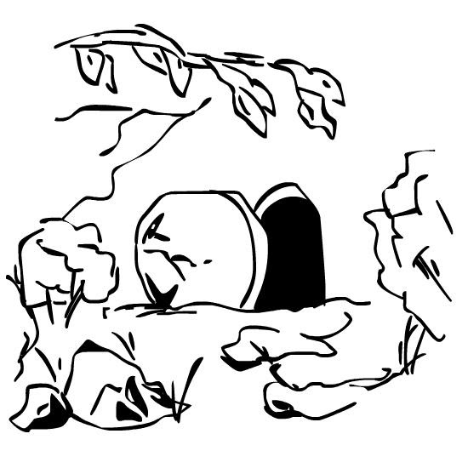

April 2021 Newsletter

Dear Friends
Easter Sunday should always focus on the death and resurrection of Jesus Christ. At the very least it’s important to retell the facts of what happened, how Jesus was crucified, died and was buried, and how on the third day He rose from the dead. That is the history of Easter, but if that was all that it was about it would be no more than an inspiration and a miracle. Even more important than the facts, though, is the Gospel message and what it means for everyone.
The Apostle Paul writes about the biggest human problem, which we can trace back to the tree in the centre of Eden. This is the tree that produced the fruit of the knowledge of good and evil, about which God instructed Adam and Eve not to eat, or else they would die. As we know, however, they were tricked by the serpent into disobeying God. As a result of this, God expelled Adam and Eve from Eden, and in time they would both die. From that point onwards every single human being was marked by that same curse.
Paul paints a vivid and horrific picture of human sin in Romans chapter 1, showing how humanity has rejected God time and again. All have sinned and fallen short of the glory of God (Romans 3:23), and the wages of sin is death (Romans 6:23). Without a redeemer, or saviour, the long-term future for everyone would be death and hell. Thank God that He had a plan to redeem us and reconcile us to Himself!
In our February newsletter we considered how God is holy. As a result of this, He must reject all people; we are separated from God because of our sin. Let me spell this out – it doesn’t matter how many good things we do in life, we are still sinners who deserve to die. It’s a bit like this: if a doctor who has discovered a cure for cancer gets into their car drunk, knocks someone over and injures them, they are still guilty of breaking the law, and deserve to be punished accordingly. We all sin, and no amount of good can ever cancel that out.
God’s justice demands that sin is properly punished, or paid for, with death. However, in sending His Son into this world, God Himself paid the price for our sin on the cross. When God looks at us He sees the holiness of His Son, Jesus, who was without sin, and because of this our wrongs are forgiven and washed away with His blood that was shed for us at Calvary. The wrath of God has been poured out on His Son, instead of us. Through faith in Jesus we are graciously forgiven and reconciled to our holy God.
This gets us as far as Good Friday, but that’s not the end of the Easter story. Jesus did not stay dead, but rose again, leaving an empty tomb and folded grave clothes behind Him. Jesus rose bodily from the dead (see Luke 24:41-43 for the ‘fishy’ proof) and revealed Himself to more than 500 different people over a period of 40 days. Jesus’ resurrection shows us that death no longer has to have the final word for us. We too will be raised with Christ at the last day, when we will receive renewed, physical bodies and we will be with God and without pain or tears (Revelation 21:4).
Easter proclaims aloud that God, in the Person of Jesus Christ, is our Redeemer and Saviour – the Gospel. Easter shows us that new life and resurrection for Jesus means eternal life and a wonderful future hope for us with God. The Lord has laid out His plans for all creation from before time began, and what He has promised, He will do. We are redeemed from what we deserved because of our sin (death and hell), forgiven and graciously granted eternal life through Jesus. It’s not the easiest of things to understand, but it is both essential and central to our faith. Without God sending His Son to die in our place we literally would be hopeless. Thanks be to God, who is our Redeemer, for Easter!
Yours, Fred.

Secretary’s notes
We heard a few weeks ago that Richard Bailey has died. Both Richard and his wife Jean were regular visitors at our Thursday lunchtime fellowship.
In the last few days we have heard the sad news that Joan Dibb died on Friday 19th March. More information will be announced so we can prayerfully support the family at this difficult time.
As we move towards the relaxation of restrictions we have a plan to gradually return to some kind of normal.
Our next in person service will be on Easter Day, 4th April, led by David Muschamp, followed by services in the hall every two weeks until the end of June, led by Fred.
On Sunday 27th June, we will hold our first service in the church, which will be led by David. This will be our first communion service in over a year, hopefully with music and singing.
The reason for this gradual reopening is to keep us all safe. We will still have to be very sensible, not hugging and try to spread out as far as seating is concerned.
Of course, these plans may change if we are given other instructions. We will keep you informed of any changes.
Janet

Addresses:
Pastor: Secretary & Treasurer: Editor: Fredrik Rich Janet & David Muschamp 1

Website: allertoncongregationalchurch.org.uk
 facebook.com/allertoncongregationalchurch

