|  |
| --- |
|  |
| ALLERTON  CONGREGATIONAL CHURCH |

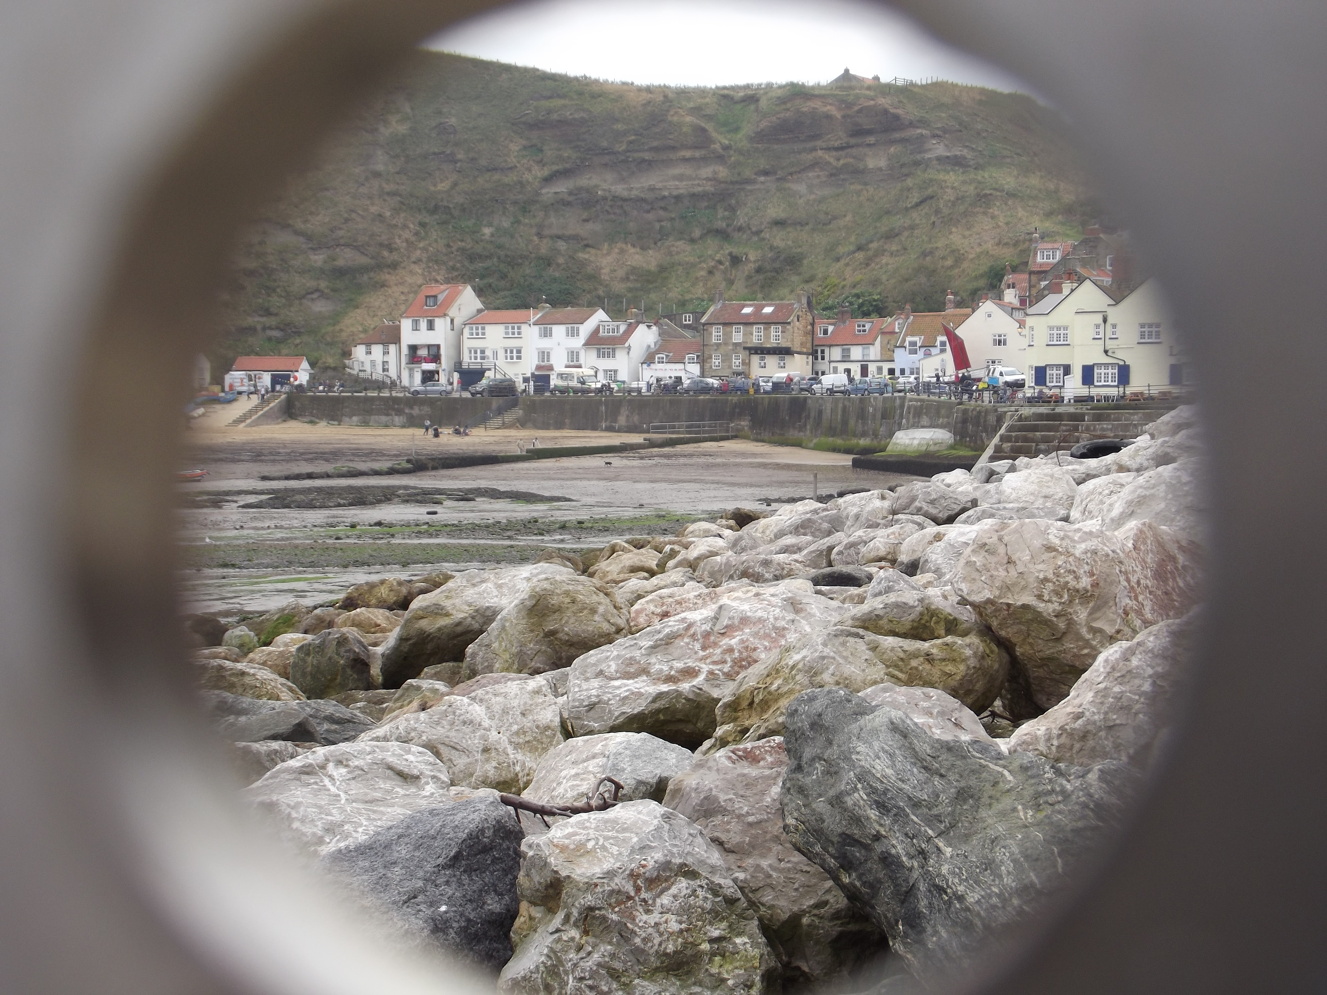

Staithes North Yorkshire taken by David Muschamp

June/July 2021 Newsletter

Dear Friends

This month I wanted to share with you why I believe meeting together as local congregations is both essential and extremely important. As local churches we meet to worship God together, hear and preach the Word, pray and have fellowship, amongst other things. The New Testament gives us clear instructions about what such gatherings should include. I have been inspired to write this article by the sermon preached on Sunday, 16thMay 2021 by Pastor James Coates of GraceLife Church of Edmonton, Alberta, Canada. His sermon was titled “The Corporate Gathering is Essential” (If you would like to watch this sermon, please email me and I will be very pleased to send you the link to the video.)

Over the past year and a bit we have been living with various restrictions on our freedoms, both personally and as local churches. There are differing views on how necessary they have all been, but clearly certain sacrifices needed to be made at certain times. It is also important to remember that not all Christians are able to attend church, due to ill health, lack of mobility and other responsibilities or commitments. Perhaps we need to be thinking of creative ways of making opportunities for Christian fellowship with those who are housebound? I really don’t have all the answers!

Clearly it is a blessing for us to be living in an age of technology, where we can watch sermons on YouTube and participate (in a limited way) in meetings by Zoom. However, this is no real substitute for being together as God’s people.

With our own congregational style of governance, and all that entails, we can understand the importance of physically being together to discern the mind of Christ. The Apostle Paul uses imagery in his first letter to the Corinthians that compares the local church to a body, which is not complete unless all members of the body are present (see 1 Corinthians 12:12-31). A body does not work if the arm is in one place, the eye in another, and the foot in a third location!

Meeting together as God’s people enables us to hear God’s Word together, receiving teaching, encouragement and challenge alike. As we gather together we can share fellowship, by which we build each other up, and encourage one another to live out the Christian life day by day.

The Apostle Paul, writing to the church at Ephesus writes as follows, “Look carefully then how you walk, not as unwise but as wise, making the best use of the time, because the days are evil. Therefore do not be foolish, but understand what the will of the Lord is. And do not get drunk with wine, for that is debauchery, but be filled with the Spirit, addressing one another in psalms and hymns and spiritual songs, singing and making melody to the Lord with your heart, giving thanks always and for everything to God the Father in the name of our Lord Jesus Christ, submitting to one another out of reverence for Christ.” (Ephesians 5:15-21)

In essence, Paul says that Christians need to employ godly wisdom, and one of the key ways in which we are to do this is through being filled with the Holy Spirit.

Note how this is something in which God does the action (the filling with the Spirit), and our part is to receive the Spirit. However, we should also note that there are various active things that we are to do as God’s people, some of which explicitly are said to be to, or for, “one another”. We cannot speak to, sing to, or encourage, one another unless we are physically together (this was the First Century, after all, when Zoom, Skype etc were not even a twinkle in their inventors’ eyes!)

In the book of Proverbs we read this saying, “Iron sharpens iron, and one man sharpens another.” (Proverbs 27:17) It is first and foremost through our being together and sharing fellowship that we can sharpen, challenge or encourage one another so that we grow in faith, love and service of our Lord. There is an old saying, ‘seven days without prayer makes one weak’. I would like to suggest that several months without meeting together makes us weaker still. So often the Bible refers to us in the plural as we relate to God in Christ. Yes, we are brought to salvation as individuals, but we do not grow and serve God without one another.

It is for these reasons, amongst others, that brothers and sisters in Christ face persecution for their faith. Meeting together is often what identifies people as Christians, and makes them visible targets for persecution. We are familiar with persecution in Iran, North Korea, China and various other Islamic or communist nations. However, I believe that there are signs of a worrying trend towards persecution of God’s people in Western nations too. We’re not there yet, but some people (myself included) see early signs in both Canada and Finland.

The Scriptures remind us that we are not to forsake meeting together (Hebrews 10:25), even if there may be negative consequences for us. Jesus warned His disciples that persecution and hardship would be their experience. Let us be aware of this and be prepared that a time may come when we, as Christians in the UK, face persecution for our faith. Let us strengthen and encourage one another in faith with the help of the Holy Spirit, meeting together for the sake of our spiritual health and Christian walk as much as is possible.

Yours, Fred.

tary’s Thoughts





 !

!"

##

 



$!#

"%& '(

)

*



+$,

"

' -

.

/0

Secretary’s Thoughts





 !

!"

##

 



$!#

"%& '(

)

*



+$,

"

' -

.

/0

Secretary’s Thoughts





 !

!"

##

 



$!#

"%& '(

)

*



+$,

"

' -

.

/0

Secretary’s Thoughts





 !

!"

##

 



$!#

"%& '(

)

*



+$,

"

' -

.

/0

Secretary’s Thoughts





 !

!"

##

 



$!#

"%& '(

)

*



+$,

"

' -

.

/0

Memorial Service for Mrs Molly Hastings

There will be a service in the church to celebrate the life of Mrs Molly Hastings on Monday, 9th August at 11.00am. The family invite all of her friends to come, and for refreshments afterwards at the Bankfield Hotel. Molly died on 8th May 2020 and her family look forward to meeting all of those who knew her.

Ian Hastings

Joan Dibb – an appreciation

Joan Dibb, a long term member of our church, passed away on 20th March this year, after a short illness.

Joan was a regular Church member and was always happy to help anyone anytime. She was always ready to pick up people to take to services and take them back home.

Joan served on the diaconate and finance committee for many years and was also a member of the choir and the Ladies Circle.

Joan always helped organise the harvest supper and helped cook the food on the day. Whilst visiting relatives in Paris, she always brought back cheeses and wine for the supper. She will be sadly missed.

Yvonne and Trevor

Secretary’s Thoughts

It is looking as though we are almost back to normal. As a church we have worked well together, keeping each other safe and keeping in touch. We had our first Deacons’ Meeting on 5th May. It was good to catch up and see people’s faces again. The plan is to have a brief church meeting sometime in August after morning service.

Our first service with music and singing will be in ‘Church’ on 27th June and the following week will be a communion service, as safely as possible, on 4th July.

At the moment I am trying to fill the preaching and organ rota so we should be all systems go!

We will not have coffee for the first few weeks. I think we still need to be cautious and very careful. We will need to still use masks and hand gel and spread out as much as possible.

Thank you for all your encouragement and support over the last very trying 15 months.

Janet

A Sheep Quiz – from Shipley Baptist Church email 26/4/21

1. Why do sheep like Christmas?

2. Which bank do sheep use?

3. Which shop do sheep like best? (Well, used to use before it closed down!)

4. So which shop do sheep prefer now?

5. Who is the strongest sheep in the world?

6. What is a sheep’s favourite drink?

7. Which country do sheep go to, to visit a farmyard friend?

8. What is the job that most lambs want when they grow up?

9. Who is the sheep’s favourite TV character?

10. Who is the lambs’ favourite TV character?

11. Where is the Woolball World Cup final held?

12. What is the sheep’s favourite pantomime?

Answers on back page

Note from the Editor Next newsletter due 25th July – please let me have any items for inclusion by 18th July. Thank you - David

Greetings from the Copley family

I had an email from Richard Copley to let me know that Shirley has moved from Bingley to a residential home in Cross Hills, where she is safe and well and receiving 24-hour care from the staff there. Her increasing dementia and blindness made it impossible for her to live independently, even with family support. Shirley still misses the church and Allerton in general. With the easing of lockdown, they are hoping to be able to take her for days out with the family.

Richard’s phone number is 07793 166787, if anyone wants to make contact.

Preaching list for June and July

Sunday 13th June Fred Rich

27th June David Muschamp

4th July Fred Rich – Communion

11th July Gordon Sitch

18th July Fred Rich

25th July Trevor Hippey

Bible Reading Rota and Coffee rota

If you would like to offer to read the Bible for Sunday services, the Bible reading rota is on the notice board in the vestibule.

As we are hoping to return to having coffee in a few weeks time, the coffee rota will be available once the starting date has been agreed.

Church Flowers

Thank you for all the extra donations for flowers, which is much appreciated, however we have not had any offers for arranging the flowers, we appreciate that this can be difficult for a lot of our members. At the moment we have 5 ladies to arrange the flowers, so to make things easier it is proposed that we do not put fresh flowers in church every Sunday.

As the ladies from the Ladies Circle are not meeting at the moment to discuss our options, Jenny and I will get together to put a plan together, but obviously some of our members donate flowers for a special date, therefore I would appreciate it if you could either speak to Jenny, myself or put your chosen special date on the flower list at church. I feel hopeful that working together we can put something in place to meet the needs of everyone.

Could you please let me know if you receive money from outside the church so we know exactly what money is coming in.

For the Sundays when we do not have fresh flowers we could look to purchase some nice flower displays.

I look forward to your thoughts and opinions.

Carole

Addresses:

Pastor: Secretary & Treasurer: Editor (temp): Fredrik Rich Janet & David Muschamp David Muschamp 1 The Sycamores Thimble Stones View

Riddlesden 56 Rudding Avenue

Keighley Allerton, Bradford BD20 5EF BD15 7DS

01274 542859

01535 531966 07837 441784 (Janet)

07570 801863 07530 727616 (David)

[Frich107uk@sky.com](mailto:Frich107uk@sky.com) [david.muschamp47@btinternet.com](mailto:david.muschamp47@btinternet.com)

## Website: allertoncongregationalchurch.org.uk

** facebook.com/allertoncongregationalchurch**

Answers to the Sheep Quiz

I. It’s Ewe-ltide. 2. Baa- clays. 3. Woollies( Woolworths)

4. Home Baa-gains. 5. Baa-nold Schwarzenegger.

6. Lemon baa-rley water. 7. Ewe-gander. 8. Baa- man.

9. Baart Simpson 10. Baa-baa the Elephant.

11. Baa-Celona. 12. Ali Baa Baa and the Forty Thieves.