|  |
| --- |
|  |
| ALLERTON  CONGREGATIONAL CHURCH |

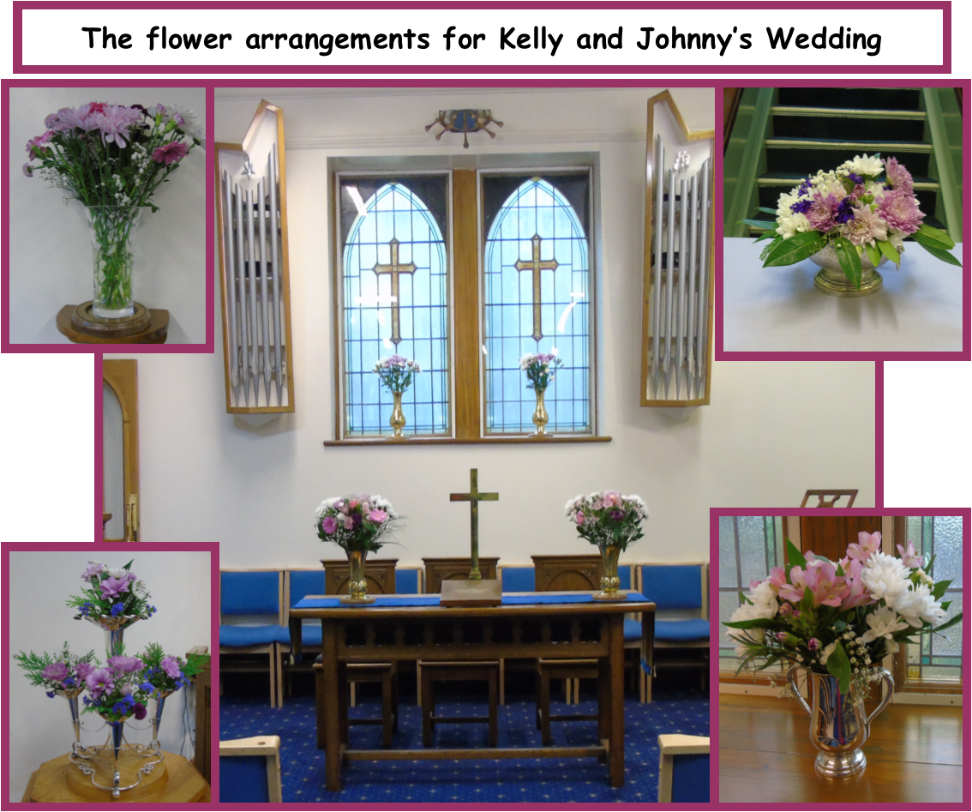

October/November 2022 Newsletter

Dear Friends

On the afternoon of Thursday 8th September 2022, Her Majesty, Queen Elizabeth II passed away at Balmoral in Scotland. Earlier this year this nation celebrated the Queen’s Platinum Jubilee through various events, remembering how she had served the nation in so many ways over the past 60 years. At her death she was Britain’s longest reigning monarch, and throughout her reign she had pointed beyond herself to her cornerstone, Jesus Christ. She regularly referred to her Christian faith, and spoke of it in detail during her Christmas Day speeches each year. Regardless of our personal views about the Monarchy, I believe that we can all appreciate the witness and service that Queen Elizabeth II gave to us.

Perhaps it is appropriate at this time for us to look to the example of probably Israel’s greatest human king, David. His death is recorded for us in 1 Kings 2, where we are informed that he died at the age of 70, having reigned for 40 years over Israel. David was not perfect, but as Scripture reminds us, he was “a man after his (God’s) own heart”. (1 Samuel 13:14) What I would like to share with you is this – the words David spoke to his son, Solomon, before he died.

Although these words were specifically addressed to Solomon, there is much godly wisdom here from which all of us who follow Jesus could learn. David tells Solomon to “keep the charge of the Lord your God, walking in his ways and keeping his statutes, his commandments, his rules, and his testimonies” (1 Kings 2:3). In other words, obedience, or fear of the Lord, is the beginning of godly wisdom (Proverbs 9:10).

By following God, through obedience to His written Word, we are choosing to live wisely, as it would seem did Queen Elizabeth II. This is good for all people, from beggars to kings and queens, and everyone in between. By living in faithful obedience to God our Saviour, we are providing a good witness to those around us, who in turn may be given the gift of faith by God’s Holy Spirit so that they too may enter eternal life.

David also speaks of a connected promise for those who will live in obedience – “that you may prosper in all that you do and wherever you turn”. It’s important that we understand this promise correctly and in context. This is not talking about material wealth or possessions, but rather something far greater. Looking forward, beyond his time, David speaks of the blessing of life in God.

This is a foreshadowing of eternal life in and through God’s Son, Jesus Christ. Ultimately it is not our obedience that gains us everlasting life, but rather the obedience and death of Jesus in our place.

My prayer at this time is for us all to look to the One who has perfectly kept all of God’s commandments. It is through faith in Him alone that we can truly prosper by entering into eternal life with Jesus. Let us also pray for our new King, His Majesty Charles III as he seeks to reign over our nation. May he look to the Saviour, Jesus Christ and find wisdom, love, compassion and eternal life in Him.

Yours Fred

Secretary’s Thoughts

Wendy Keeton: Wendy sadly passed away on 14th August in Pennine Lodge at Todmorden, where she had been cared for since 2015. She had been a member of the Church for many years having been involved in worship, the Fellowship Group and in many productions of the Amateur Operatic Society. Belinda and Neil were delighted at the number of Wendy’s friends who joined them for the celebration of her life at Nab Wood on Thursday 15th September.

Tribute to Queen Elizabeth II: We were all saddened at the news of the death of the Queen and join with the nation in our prayerful support for the Royal Family at this time.

Kelly and John’s Wedding: The Wedding of Kelly Pollard and Johnny Hutchinson was held in our Church on Saturday 9th September, conducted by Fred. We send our best wishes to the happy couple for their marriage.

Donald’s 100th Birthday Celebration: It was wonderful that so many of us were be able to join with family and friends on the very happy occasion of the 100th birthday party for Donald Roberts at Bingley Arts Centre on 2nd September.

Prayer Meeting: Monthly prayer meetings are planned for the first Wednesday in the month commencing on 5th October at 10.30am.

Bible Study Group: Fred is planning a series of four Bible Studies on Friday mornings in November on 4th, 11th, 18th and 25th at 10.00am.

Dates for your Diary

Saturday 1st October - 10.00am to 12.00 noon – Coffee Morning.

Sunday 23rd October – Church Meeting after morning service – any items for inclusion in Any Other Business to be notified to the Secretary by 16th October.

Fridays 4th, 11th, 18th, 25th November – 10.00am – Bible Study.

Saturday 19th November - 3.00pm – Bradford District Scouts Gang Show – Tickets available £5 (including tea/coffee).

Janet

Flower Rota – flowers provided by:

October 2022

2nd Mr & Mrs P Barfield

9th Mr & Mrs B Haley

16th Mrs Brown

23rd Mrs A Henderson

November

6th Mrs J Holdsworth & Mr & Mrs J Jones

13th Mrs I Relton

20th Mrs & Mrs I Hastings

27th Mrs M Fletcher

Carole

On Sundays not listed, silk flowers will be used.

Preaching list for October and November

October Preachers

2nd Trevor Kershaw – Christening (not Communion)

9th Gordon Sitch

16th Rev Fred Rich - Church Anniversary and Communion

23rd  Rev Allen Holmes

30th  Rev Richard Lewis

November Preachers

6th Rev Fred Rich – Communion

13th Trevor Hippey – Remembrance Sunday

20th  Trevor Kershaw

27th Rev Fred Rich

Finance Committee – A message from the Financial Secretary

Building Update

The repair of the hall ceiling continues to prove a severe challenge to find any contractor willing to carry out this work. Two contractors have been to inspect the work, both went away to quote, but in the end both declined. The search continues.

On a brighter note, the rear boundary wall had a partial collapse, but this was fixed in a matter of days at little cost, if only masons could repair ceilings!

Chris

Coffee Rota

As we have returned to having coffee after services, it would be really helpful if those on the rota could come a little earlier to set things up. You will not need to bring milk.

The coffee rota is on the notice board in the vestibule and will be on the table in the hall on Sundays.

Bible Reading Rota

If you would like to offer to read the Bible for Sunday services, the Bible reading rota is on the notice board in the vestibule and will be on the table in the hall on Sundays.

Note from the Editor

The next newsletter is due on 27th November – please let me have any items for inclusion by 20th November.

Thank you – Carole

Sundays - Services at 10.30 am.

## Website: allertoncongregationalchurch.org.uk

 **facebook.com/allertoncongregationalchurch**