|  |
| --- |
|  |
| ALLERTON  CONGREGATIONAL CHURCH |

|  |
| --- |
| **Wishing everyone a Happy Easter** |



April/May 2023 Newsletter

Dear Friends

Doesn’t time fly? It has already been just over 5 years since I became your pastor here at Allerton Congregational Church. In that time much has happened, some good and some not so good. Having said that, though, I believe it’s best for us all to continue to look forward to the journey of Christian faith still in front of us. More important than anything else, I hope that I can say that over the past 5 and a bit years I can agree with the Apostle Paul in saying that I have “decided to know nothing among you except Jesus Christ and him crucified.” (1 Corinthians 2:2). As we approach Easter I believe that this is a great place for us to start our thoughts about this time in the Church year.

Regardless of the issues we face individually, or together as a church fellowship, we need to look to Jesus Christ and Him crucified. Without the cross we have no Christianity, as we would still be dead in our sin and alienated from a holy God. Thankfully, though, our faith is not in vain. Not only did Jesus die in our place on the cross, paying the price for our sin so that we might be forgiven and reconciled back to God, but He also rose again from the dead.

Later in the same letter, Paul wrote, “if Christ has not been raised, then our preaching is in vain and your faith is in vain.” (1 Corinthians 15:14) Why does Paul say that Jesus’ resurrection is essential to the Christian faith? I’m sure that we all understand that Jesus’ death is essential for our forgiveness and entry into God’s family. However, His resurrection doesn’t seem to have quite the same significance. What does the Apostle Paul have to say about this? Later in the same chapter he writes, “If in Christ we have hope in this life only, we are of all people most to be pitied.” (v.19)

In other words, Jesus’ resurrection is a foretaste of the fact that we will all be raised again to life in the future. Our hope is not just for the here and now, but it is for eternity. By rising from the dead, Jesus has shown us that resurrection can happen and that what He said was true. We have a sure hope for the future because Christ is risen! It demonstrates for us that “The last enemy to be destroyed is death.” (v.26), and through His resurrection Jesus has won the victory over it. We can be confident that Jesus is who He said He was, and that He has done what the Scriptures say He has done for us. We have better historical evidence for Jesus’ resurrection than we do for Caesar’s invasion of Britain, which no-one ever seems to seriously question. As great as such evidence might be for Jesus’ literal and physical death and resurrection, without God’s gift of faith, we cannot truly trust God.

Explanations, facts and even witness statements (such as we find in the New Testament Gospels) only get us so far. We are only saved from God’s right judgment because of God’s gracious gift of faith, given us by His Holy Spirit. It is not down to us and our efforts or actions, but is rather entirely down to the direct act of God because of His grace, mercy and love towards us which He has shown us and revealed to us in and through His Son, Jesus Christ. To Him alone belongs the glory!

Yours Fred

Secretary’s Thoughts

Well – the snow stopped us all doing what we needed to do. As we all get older, we find it more difficult to get around when it’s snowy or icy and clearing snow is impossible. Let’s hope we manage April without significant snow fall.

During Holy Week, we have a service on Maundy Thursday, 6th April at 12.00 noon, followed by a lunch of soup. There will also be a service on Good Friday at Bethel, Sandy Lane from 10.00 till 10.30am to which we have been invited.

As the clocks will have moved forward by the time you read this newsletter, we have lighter nights and, hopefully, much better weather to look forward to as well as another date for your diaries.

We have the concert with John Froud and Daughter on Saturday 22nd April at 7.00 pm. This is a joint venture with Bethel, and promises to be ‘A Good Do’.

I also mentioned in the last newsletter that we have 3 Bank Holidays to look forward to in May, including the Coronation of King Charles III.

Janet

Treasurer’s Reflection

Many thanks to all those who gave to the DEC Earthquake Appeal for Turkey and Syria, a total of £200.00 was sent off on your behalf.

I have also sent off the last donation of used stamps to The Leprosy Mission. Many thanks to all who have supported this fund raising effort over the last few years.

I received a cutting from the T&A which was asking for used stamps for Guide Dogs for the Blind, so, hopefully, we will be able to continue to collect used stamps for a worthy cause. Watch out for a new collecting box.

David

Dates for your Diary

Maundy Thursday 6th April 12.00 noon – Service at ACC + lunch

Good Friday 7th April 10.00 – 10.30m – Service at Bethel, Sandy Lane

Saturday 15th April – Coffee Morning at Riddlesden URC - 10.00am

Saturday 22nd April – Concert with John Froud and Cath – 7.00pm

Tuesday 2nd May – Finance Committee – 10.00am

Tuesday 9th May – Deacons Meeting – 10.00am

Saturday 13th May – Christian Aid Coffee Morning – 10am-12noon

Saturday 20th May – Coffee Morning at Riddlesden RC – 10.00am

Saturday 10th June – Leprosy Mission Coffee Morning – 10am-12noon

Saturday 17th June – Coffee Morning at Riddlesden URC – 10.00am

Saturday 15th July - Ladies Circle Coffee Morning – 10am-12noon

Saturday 23rd September – Harvest Supper – 4.00pm

Saturday 25th November – Christmas Coffee Shop – 10am-12noon.

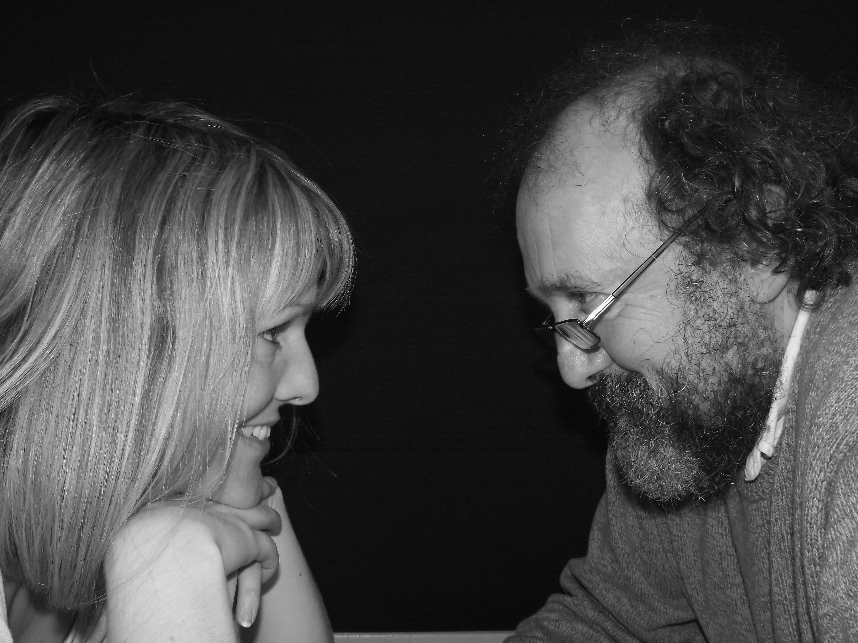

**FROUD & DAUGHTER**

**John & Cath in Concert**

**Singing songs of faith, hope and love**

**Allerton Congregational Church**

**Saturday 22nd April at 7.00pm**

**Admission Free**

**Refreshments will be served**

Flower Rota – flowers provided by:

|  |  |  |  |
| --- | --- | --- | --- |
| April 2023 | | May 2023 | |
| 2nd | Mrs W Hume | 28th | Mr C Thorp (Memory of Mrs S Thorp) |
| 9th | Mr & Mrs Breen |  |  |
| 23rd | Mr & Mrs Collier-Drake |  |  |

On Sundays not listed, silk flowers will be used.

Preaching list

|  |  |  |  |
| --- | --- | --- | --- |
| April 2023 | | May 2023 | |
| 02nd | Rev Fred Rich | 7th | Rev David Muschamp |
| 9th | Rev David Muschamp | 14th | Rev Fred Rich |
| 16th | Rev Allen Holmes | 21st | Rev Fred Rich |
| 23rd | Rev Fred Rich | 28th | Rev David Muschamp |
| 30th | Mr Trevor Hippey |  |  |

Finance Committee – A message from the Financial Secretary

It is great to report that the long awaited repair works to the main hall ceiling have now been completed. Hopefully everyone who inspects the work will struggle to actually see where the repair has been done, it is that good.

At the same time that the ceiling was repaired, the dry rot by the back door has also been repaired and this too is a good job.

We have also just renewed the Church Insurances and have again entered into a long term undertaking with our existing insurers of many years to secure a 25% discount. However, before renewing we made approaches to two other insurers and can confirm we this is a very competitive deal.

Coffee Rota

As we have returned to having coffee after services, it would be really helpful if those on the rota could come a little earlier to set things up. You will not need to bring milk.

The coffee rota is on the notice board in the vestibule and will be on the table in the hall on Sundays.

Bible Reading Rota

If you would like to offer to read the Bible for Sunday services, the Bible reading rota is on the notice board in the vestibule and will be on the table in the hall on Sundays.

Note from the Editor

The next newsletter is due on 28th May 2023 – please let me have any items for inclusion by 21st May 2023.

Thank you – Carole

Sundays - Services at 10.30 am.

Addresses:

Pastor: Secretary & Treasurer: Editor: Fredrik Rich Janet & David Muschamp Carole Brook 1 The Sycamores Thimble Stones View

Riddlesden 56 Rudding Avenue

Keighley Allerton, Bradford BD20 5EF BD15 7DS

01274 542859

01535 531966 07837 441784 (Janet)

07570 801863 07530 727616 (David)

[Frich107uk@sky.com](mailto:Frich107uk@sky.com) [david.muschamp47@btinternet.com](mailto:david.muschamp47@btinternet.com)

## Website: allertoncongregationalchurch.org.uk

 **facebook.com/allertoncongregationalchurch**