|  |
| --- |
|  |
| ALLERTON  CONGREGATIONAL CHURCH |

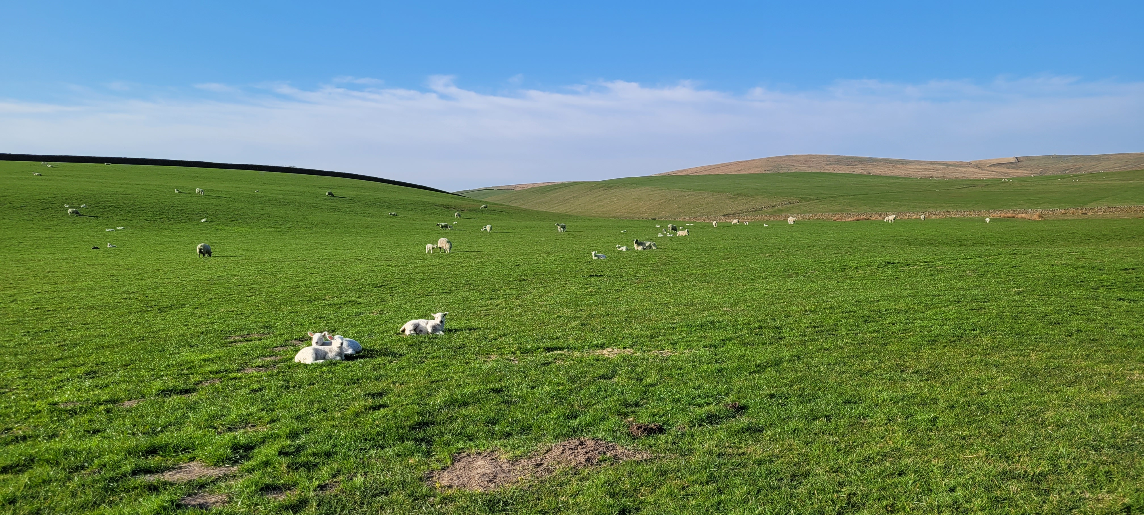

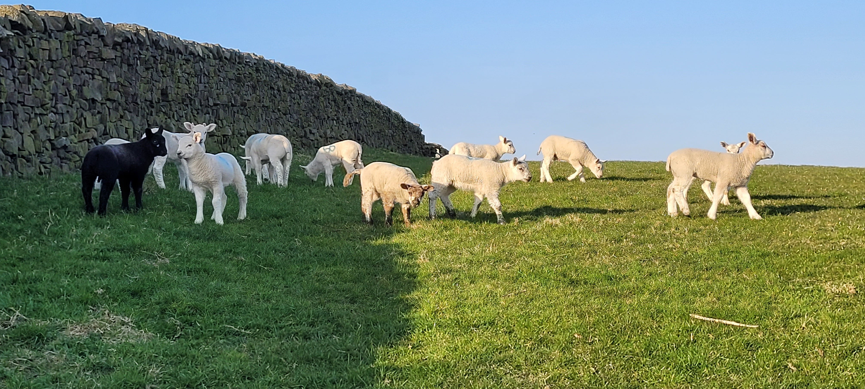

May/June 2025 Newsletter

Dear Friends

Where do I start, I certainly wasn’t expecting to be writing for the May newsletter but here I am, sat at my computer wondering what to say.

Ironically, we’re currently in Holy Week but that will have passed by the time you read this. Holy Week is a turbulent time. Our early steps through Lent have given way to more serious thought as Passion Sunday leads to Palm Sunday and from there into Holy Week. It was a turbulent time for Jesus and his followers just as the past couple of months have been for Allerton Congregational Church. Although Jesus knew what was about to happen no one else did, his disciples and other followers were oblivious to how Easter would unfold despite Jesus having many attempts to explain it to them. By the time Good Friday arrived Jesus was on the cross, his disciples were diving for cover and the plan, if there was one, seems to be out of the window.

But not so, read on, there’s more. The desperation, suffering and pain of Good Friday gives way to Easter Day. The dark clouds which had gathered have dispersed, the sun is shining, and Jesus is Risen. Things are looking up and even though the disciples didn’t understand how it all happened they were glad it had. After a period of hesitancy, order of a kind was restored, and even enthusiasm began to shine through. Eventually Pentecost arrived, the Holy Spirit came, and we all know what happened next. What a wonderful time to be a follower of Jesus.

The events around that first Easter must have seemed like utter chaos to the followers of Jesus, out of control and heading towards disaster but if you think that, you discount the hand of God in all that took place. God was conducting in perfect harmony, everything was going to plan and in order for the future to offer all people forgiveness from sins and everlasting life Jesus had to go to the cross, die and rise again. No one could see that coming, but God had everything in under control.

I find that so reassuring, that in the turmoil and chaos of the world’s issues, our God reigns. In the lives of ordinary people there’s constant ebb and flows, ups and downs and joys and sorrows, but our God reigns and in our hearts where sometimes we have doubts and our faith might be tested, our God reigns. It therefore also follows that in our church which has been rocked by recent events, our God reigns.

There is much for us to do and we need to be together as we move forward but it is my firm belief that God has our best interests at heart and even though we can’t always see his way forward very clearly we must have the faith to believe that God holds us in his hands and will help us in the weeks and months to come. It’s not going to be easy and there will be many challenges just as there was for Jesus and the disciples through the Easter period but eventually Christ was Risen and Pentecost was just around the corner. May it be the same for us and may our God reign, in our hearts, in our lives and in our church.

With love Trevor

**Donald Roberts**

It was with great sadness that we learnt of the passing of Donald Roberts. Donald was born in 1922 and lived well and happily for over 102 years, rarely showing his age and always enjoying life to the full. A stalwart of our church for so many years Donald first came to Allerton Congs in 1946 where he met Margaret Robertshaw. They married here in 1948 and made this their spiritual home, attending both morning and evening service and sharing their love of Gilbert & Sullivan and all things Operatic. Donald served the church in many capacities over the years, and we will miss him dearly. We send our sincere condolences to Susan, Ron, Faye, Gayle and their families. A service of celebration for Donald’s life will be held at church on 2nd May starting at 12.15pm.

**Many Thanks**

As most of you will know David and Janet plan to stand down at the AGM from their positions of Church Treasurer and Church Secretary. Both have held their roles for many years and during that time have covered a myriad of jobs which were never on their job descriptions. Jobs which many of us don’t even see or know need doing but they have been

done very willingly by David and Janet. They have served our church in many different ways, and we are so grateful for the time, effort and dedication they have shown. But all good things come to an end eventually and David and Janet feel it’s time to step down and take a break and who can blame them for that after so many years’ service. David and Janet, we wish you well, you go with our love and thanks, we look forward to you worshipping with us in the future with not quite the same responsibility on your shoulders. Thank you so much for everything you have done**.**

**Situations Vacant**

In view of David and Janet standing down we have some vacancies to fill. Please consider whether you have time to serve the church as either Church Treasurer or Church Secretary, or you are willing to help by working with someone else to fill these roles. We also have vacancies for Deacons, at present we have six but when David and Janet stand

down there will only be four. That puts a huge burden on Trevor, Yvonne, Susan and Carole. Please have a think if you could help. These are all roles that should be filled by church members and It’s important for the future of the church that the work is shared rather than it falling on the same people. Thank you for giving this matter your thoughts and prayers. If you would like to discuss any of these roles please speak to Trevor, Chris or one of the Deacons. Thank you.

**Church Family Lunch**

A date for your diary. A church family lunch will take place after the service on Sunday 29th June to which everyone is invited. This will not only give us chance to share fellowship

together but also discuss the way forward for our church. Nearer the time a list will appear on the noticeboard for names and any dietary requirements. The cost of the buffet lunch will be met through church funds, everyone is welcome, and we hope as many as possible will be able to attend.

**Finance Report**

The front boundary wall has been rebuilt following the damage caused by the fallen tree last August. The railing need to be replaced and this will follow shortly. The rebuilt wall looks good and a great improvement on the original which was showing its age. At the same time a repair was done to the wall behind Church.

Two large trees have also been removed from the front of church. One of the trees was dead but the other was so large it was masking the road light in Allerton Road. The removal has also removed any pressure on the boundary wall at the corner of the church grounds although a further repair in the future may be necessary.

After many years good service our gardener David Inman has retired so we wish him a long and happy retirement. A new gardener has taken over this work.

Thanks Chris

**Dates for your Diary**

Sunday 11th May - AGM following service

Sunday 29th June – Church Meeting and Lunch after service

Saturday 12th July - Ladies Circle Coffee Morning

**Flower Rota** – flowers provided by:

|  |  |  |  |
| --- | --- | --- | --- |
| May 2025 | | June 2025 | |
| 10th | Mrs J Clough | 15th | Mrs P Barfield |

On Sundays not listed, silk flowers will be used.

Preaching list

|  |  |  |  |  |
| --- | --- | --- | --- | --- |
| May 25 | |  | June 25 | |
| 4th | Ian Huddleston |  | 1st | Gordon Stitch |
| 11th | Trevor Kershaw |  | 8th | Trevor Kershaw |
| 18th | Rev Helen Keighley |  | 15th | TBA |
| 25th | Trevor Kershaw |  | 22nd | David Robinson |
|  |  |  | 29th | Trevor Kershaw |

Coffee Rota

It would be really helpful if those on the rota could come a little earlier to set things up. You will not need to bring milk.

The coffee rota is on the notice board in the vestibule and will be on the table in the hall on Sundays.

**Bible Reading Rota**

If you would like to offer to read the Bible for Sunday services, the Bible reading rota is on the notice board in the vestibule and will be on the table in the hall on Sundays.

Note from the Editor

The next newsletter is due on 29th June 2025 – please let me have any items for inclusion by 21st June 2025.

Thank you Carole

Sundays - Services at 10.30 am.

Addresses:

|  |  |  |  |
| --- | --- | --- | --- |
| **Pastor** | **Treasurer** | **Secretary** | **Editor** |
| Trevor Kershaw |  |  | Carole Brook |
| Mobile:  07811 888348 |  |  |  |
|  |  |  |  |
|  |  |  |  |

## Website: allertoncongregationalchurch.org.uk

 **facebook.com/allertoncongregationalchurch**