ALLERTON
CONGREGATIONAL CHURCH

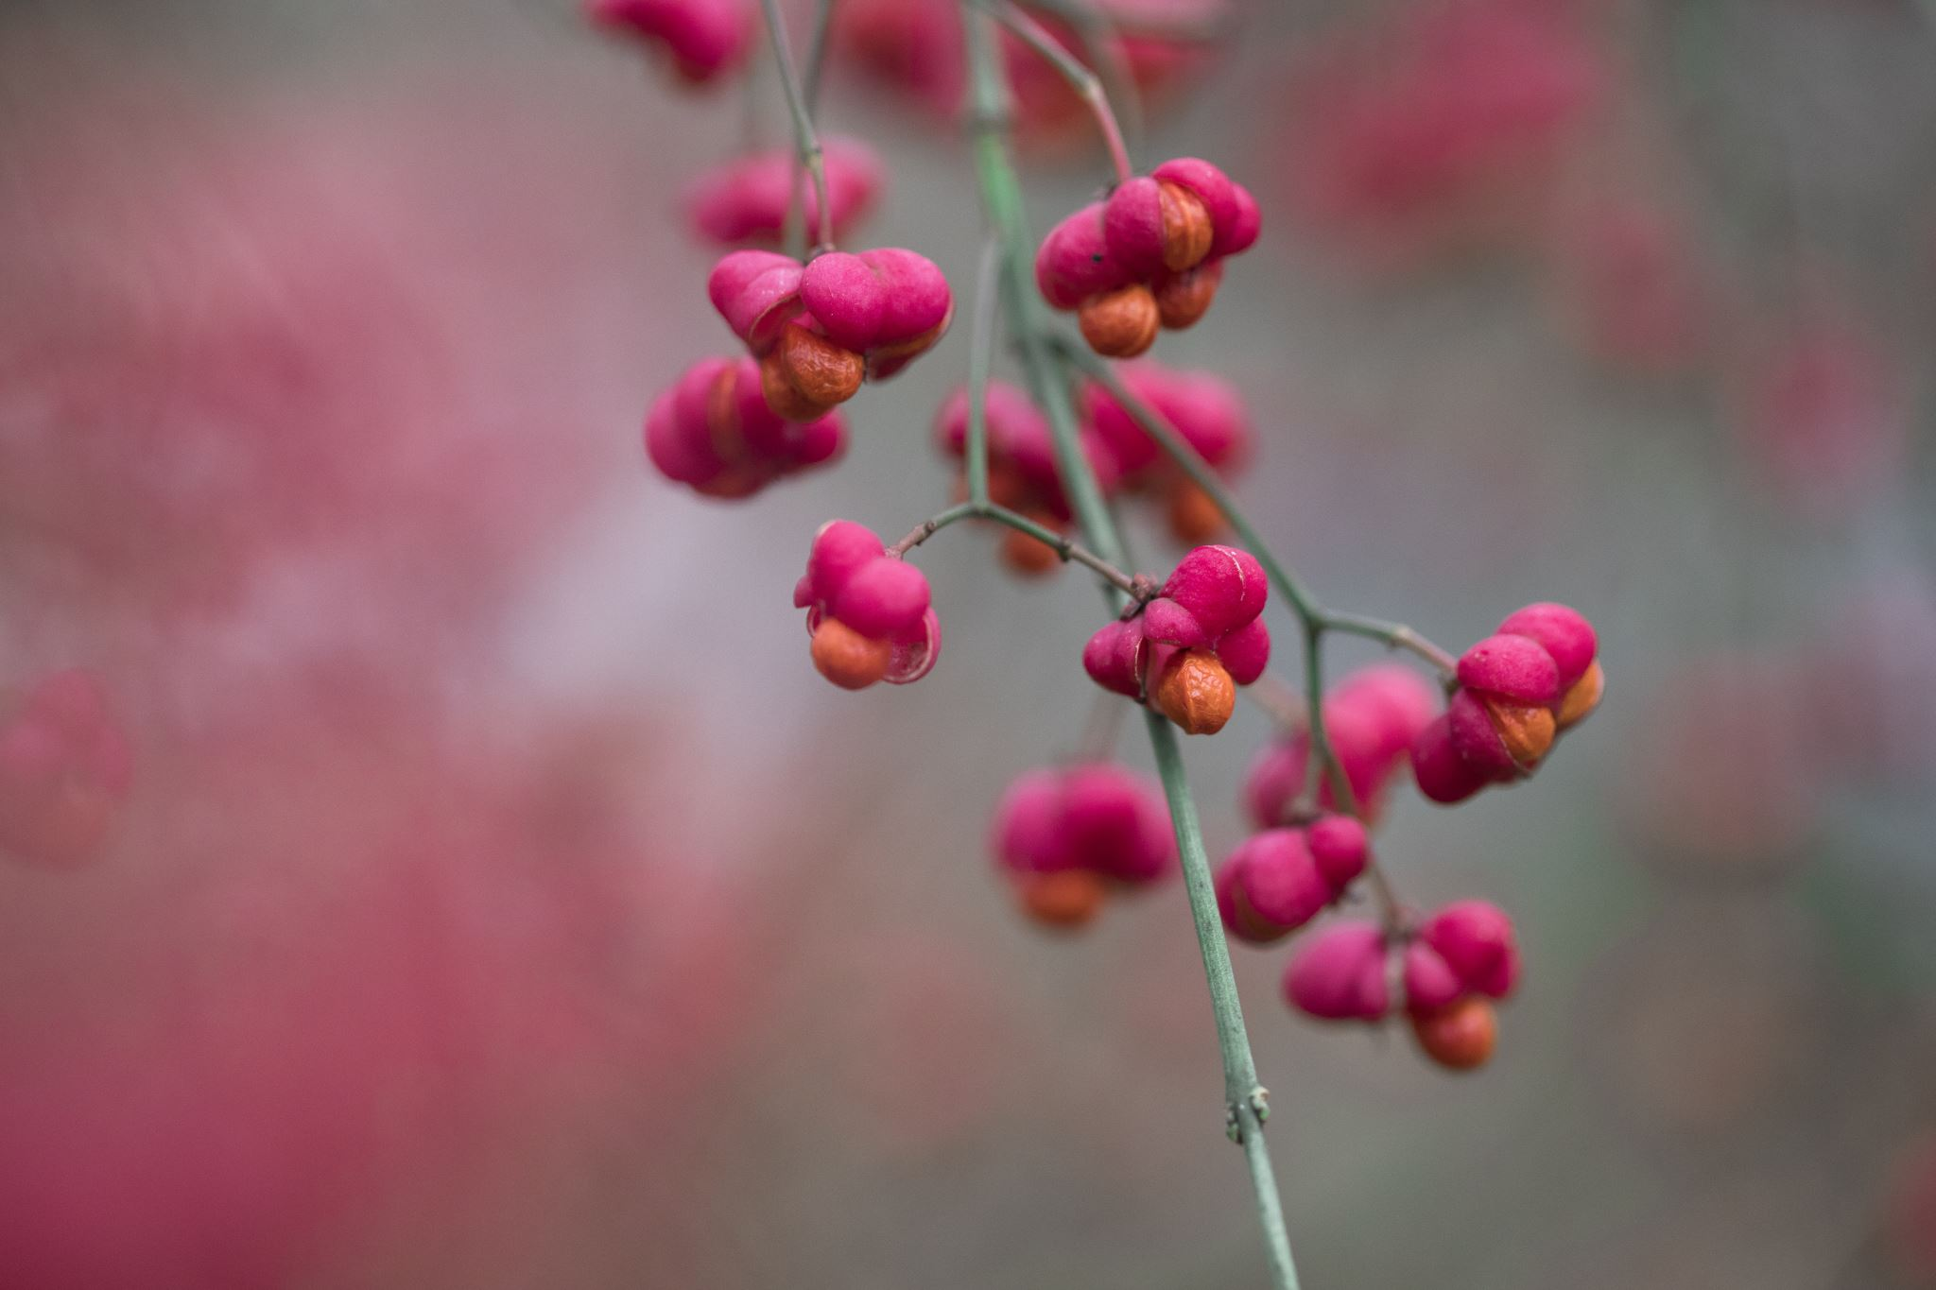

November/December 2025 Newsletter
Dear Friends
This is my November and December greeting but It’s a bit early to start wishing you all a Merry Christmas. Having said that the retail sector has been promoting Christmas cards and presents for a month or too already, so maybe it’s not too early.
Merry Christmas everyone!!
Seriously though lots of water will pass under the bridge until we can genuinely share our Christmas greetings and enjoy the celebrations. I can think of two important events between now and Christmas which really, we should focus on first.
Remembrance Sunday and Advent.
On Remembrance Sunday I will be addressing the crowds at the Cenotaph in Shelf, and I mean crowds. The last time I was there, numbers were in the hundreds, all gathered to remember and say thank you to those who fought and died in the Great Wars and in conflicts since. Quite recently we visited Bletchley Park and it’s a stark reminder of the dedication of many thousands whose work was not on the battle fields but on secret missions which opened enemy lines and gained us a valuable advantage. We are so grateful to all those involved. Remembrance Sunday is an important day in our calendar and long may it remain so. How different life might have been had those heroes not given so much for our sake. And then there’s the season of Advent which offers us a time to prepare for Christmas spiritually as we build up to the coming of Jesus into the world. When we read the Old Testament, we recall how long the people of the day had to wait for the promised Messiah. Generation after generation waited for a new King and finally, he came, born in a stable. Not a king of battle and might but a king of humility and love. Jesus was his name, he was God incarnate, God made man, and eventually from lowly beginnings this King of Love gave his life for the good of humanity. He became a hero to those who generation after generation have accepted him as their Saviour and celebrated his life, death and resurrection. I hope Advent is a meaningful season for you, a reflective season of peace and quiet in the build-up to an often hurly burly corporate Christmas.
The next two months will come and go just as they always have but take a moment to reflect on those who gave their lives for you and allow them to be the focus of your appreciation and love.
With every blessing
Trevor

Finance/Property Report
We can report that all work to repair the front wall following the tree damage has been completed. Whilst looking at the front, you may also see that the Noticeboard now has lists of Preachers and other notices. Plans are also in hand to change the banner.

Issues with the electrics continue to cause issues, the latest being the “fishy smell” some of you may have been aware of when the hall heaters are used. This issue has been repaired but there is a bigger issue with the old distribution board which has reached the end of it safe working life. Our dispute with the Smart meter continues and is now subject to a complaint to the Energy Ombudsman.

Cleaning of the Church premises since around 2004 has been carried out by David Jagger who has now retired through ill health. The Members sent him a Card and small gift as an appreciation of his dedicated service, which he was duly appreciate of. We have been fortunate to find and appoint a new cleaning company, Cathy’s Domestic Services from Baildon.

Christopher Ing
Financial Secretary

Dates for your Diary 2025
Friday 7th November Memories of Growing up in Allerton.
Wednesday 19th November – Hall trimming, everyone welcome, refreshments will be served between 10am and 12noon.
Saturday 22nd November – Christmas Coffee Shop, normal coffee morning arrangements 10am to 12noon, £2 admission, refreshment served throughout. Cake Stall, Books, Cards etc
Friday 12th December Sue H & Carole B New Zealand Talk, followed by Christmas Cake and Mince Pies.
Sunday 14th December Carol Service, 10:30am, favourite carols with prayers, readings and reflections. Everyone welcome. Followed by lunch. More details to follow.
A reminder that we decided not to have a Christmas Day service this year.

Happy Memories
A suggestion has been made to collect and display happy memories of our past here at church which can be shared with everyone. This is a great way to celebrate our past and reminisce over a cuppa!
A display will be put on the wall in the hall and everyone is invited to share their stories and happy memories of times gone by.
If you have a photo to go with your story please include it!!
If you have a story to share please write it down and pass to Sue Howard or email it to suehoward01@btinternet.com
So please get your thinking caps on and start your story with “I remember when……..”

As a starter you may have stories about The at Homes, Ladies Circle, Allerton Operatic Society, Brownies and Guides, Summer Fairs at a High Ash Farm and at church, Anniversary Celebrations, Sunday School, Coffee Mornings.

Macmillan coffee morning September 27th 2025
Thank you to all who supported the coffee morning- to those who baked cakes, scones, biscuits and gave raffle prizes, to those who gave donations or simply turned up to join us. Thank you to the church for the use of the premises and generous donation. There was a good positive friendly atmosphere- numerous people remarked on this- which made all our efforts worthwhile, for the vital work which Macmillan undertakes. The final sum raised is an amazing £500 gratefully acknowledged by Macmillan.

Thank you to everyone.
Jean, Fiona and Elizabeth.

Flower Rota – flowers provided by:
On Sundays not listed, silk flowers will be used.
November 2025 |  | December 2025
2nd | Mrs J Holdsworth & Mr A Jones | Poinsettia Plants will be displayed during December.
9th | Mrs I Relton | Poinsettia Plants will be displayed during December.
16th | Mr & Mrs I Hastings | Poinsettia Plants will be displayed during December.

Preaching list
November 2025 |  |  | December 2025
2nd | Robert Waddington |  |  | 7th | Trevor Kershaw
9th | David Robinson |  |  | 14th | Trevor Kershaw
16th | Trevor Kershaw |  |  | 21st | Hannah Mole
23rd | Janice Le Blancq |  |  | 28th
30th | David Robinson

Coffee Rota

It would be really helpful if those on the rota could come a little earlier to set things up. You will not need to bring milk.

Note from the Editor

The next newsletter is due on 21st December 2025 – please let me have any items for inclusion by 13th December 2025. Earlier dates due to Christmas.

Thank you Carole

Sundays - Services at 10.30 am.

Addresses:

Pastor | Treasurer | Secretary | Editor
Trevor Kershaw |  |  | Carole Brook
Mobile:
07811 888348

Website: allertoncongregationalchurch.org.uk
 facebook.com/allertoncongregationalchurch

